BUILD TRACK - REAL ESTATE HOUSE BUILDING INVENTORY AND PROGRESS TRACKER
TOOLS AND TECHNOLOGIES SPECIFICATION DOCUMENT
1. Frontend Technologies & Client Architecture
The frontend is the visual part of BuildTrack that users interact with. It is designed to be simple, fast, and easy to use on office desktop computers, laptops, and mobile phones used by site engineers at construction job sites. The system uses standard web technologies without heavy extra downloads, making pages load fast even on normal mobile internet connections.
• HTML5 (Web Structure & Layout): HTML5 is the backbone of all web pages in BuildTrack. It provides clean page sections (<header>, <nav>, <main>, <footer>) and handles interactive forms for recording materials, builders, and house details. The responsive viewport tag ensures that every screen automatically adjusts its size to fit phone and tablet screens cleanly.
• Bootstrap 5.3 & CSS3 (Design & Responsive Styling): Bootstrap 5 provides modern visual styling, clean buttons, cards, tables, and a 12-column grid system. Custom CSS rules in `/static/css/style.css` add clear color badges: green for completed building stages, yellow for low stock warnings, and red for critical material shortages.
• Vanilla JavaScript (Fast Browser Interactivity): BuildTrack uses pure JavaScript (ES6+) without heavy frameworks like React. JavaScript handles instant calculations on the screen (such as calculating cement costs and 18% GST), opens popup windows for fast updates, and sends data to the server smoothly without reloading the entire page.
• MediaDevices API (Live Camera & Photo Proof): To verify that construction work has actually been completed before approving stage payments, site engineers can take live photos right on the construction site using their phone or webcam. The MediaDevices API accesses the camera directly in the browser, captures the photo into an HTML5 canvas, and sends it safely to the server.
Component | Technology | Version | Simple Explanation & Purpose
Page Structure | HTML5 | W3C Standard | Builds clean web pages, forms, tables, and mobile-friendly layouts.
Styling & Theme | Bootstrap 5 & CSS3 | Version 5.3.3 | Makes pages look neat, modern, and mobile-responsive with color badges.
Browser Scripting | Vanilla JavaScript | ES6+ Modern | Calculates material totals and updates numbers instantly without page reload.
Camera Capture | MediaDevices API | WebRTC Standard | Allows site engineers to capture real-time photo proof of work from their cameras.

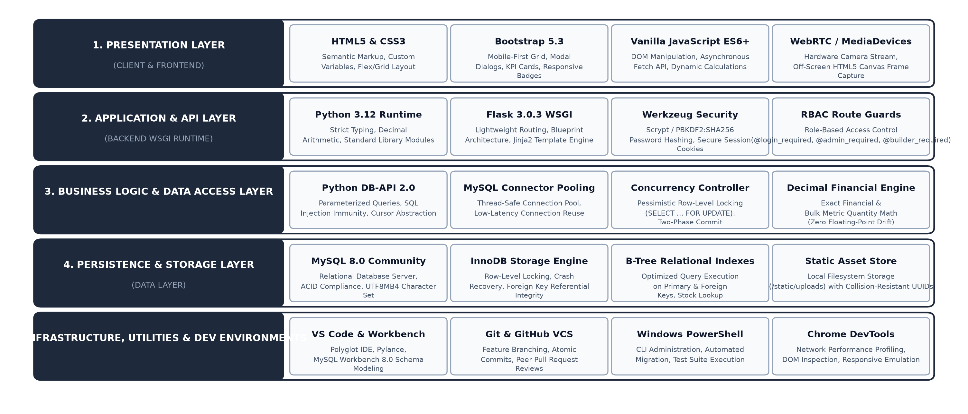
Figure 1: Multi-Tiered Technology Stack Architecture of the BuildTrack Platform.
2. Backend Architecture & Web Server
The backend is the engine of BuildTrack running on the server. It receives requests from users, checks permissions, calculates material quantities, interacts with the database, and sends back the correct information safely.
• Python 3.12 (Core Programming Language): Python 3.12 runs the core business logic. Python is chosen because it is clean, reliable, and powerful. Crucially, BuildTrack uses Python's `decimal.Decimal` module for all material quantities and monetary totals. This ensures exact math with zero decimal rounding errors, so not a single rupee or bag of cement is lost to computer math rounding.
• Flask 3.0.3 (Web Framework & URL Routing): Flask is a lightweight and fast Python web framework. It connects user clicks to the right Python functions, renders HTML pages using Jinja2 templates, and automatically passes real-time alerts (such as low cement warnings) to every page.
• Werkzeug Security (Password Protection & Safe Sessions): User passwords are encrypted using Scrypt and PBKDF2:SHA256 with 600,000 security cycles and unique salts. Even if someone accesses the database, passwords cannot be decoded. In addition, user logins are stored in tamper-proof, encrypted cookies so user sessions remain completely safe.
• Role-Based Access Control (Admin vs. Builder Security): BuildTrack checks who is logged in before showing any sensitive page. Administrators have full access to add houses, suppliers, and materials. Site engineers can only view their assigned houses and submit progress updates. Unauthorized access attempts are immediately blocked with a warning.
Component | Technology | Version | Simple Explanation & Purpose
Programming Engine | Python 3.12 | CPython 64-bit | Runs all application logic and ensures exact non-rounding math.
Web Framework | Flask WSGI | Version 3.0.3 / 3.1.3 | Connects web routes, handles user actions, and displays dashboard pages.
Template System | Jinja2 Templates | Version 3.1.6 | Merges Python data with HTML pages and stops malicious script attacks.
Password Encryption | Werkzeug Security | Scrypt / PBKDF2 | Safely encrypts user passwords with 600,000 security rounds.
Login Security | itsdangerous | Version 2.2.0 | Protects user login sessions with encrypted, tamper-proof cookies.
Role Guards | Python Decorators | Custom Wrappers | Guarantees only admins can edit stock and only builders update site logs.

3. Database Management System (MySQL 8.0)
The database stores all information permanently: house details, construction stages, materials inventory, suppliers, and worker logs. BuildTrack uses MySQL 8.0 with the InnoDB storage engine for high safety and reliability.
• InnoDB Engine & Safety: InnoDB guarantees ACID safety, meaning if a power loss occurs during a material order, data is never corrupted or half-saved.
• Safe Stock Updates (Row Locking): When multiple site engineers request cement simultaneously, MySQL uses `SELECT ... FOR UPDATE` to lock that specific row for a split second, making sure stock is updated one-by-one and never drops below zero.
• Connection Pooling: Keeps a pool of ready database connections so queries run in milliseconds without reconnecting each time.
• Fast Indexing: Uses B-Tree indexes on house IDs and material IDs so searching through hundreds of records is instantaneous.
Database Feature | Setting / Value | Simple Explanation & Purpose
Database Server | MySQL 8.0 Community | Stores all tables, inventory records, and house building stages safely.
Storage Engine | InnoDB Engine | Guarantees data safety, prevents data corruption, and protects relationships.
Concurrency Lock | SELECT ... FOR UPDATE | Locks material rows during updates so stock never goes negative by accident.
Connection Pool | Pool Size = 10 | Keeps pre-opened connections ready so dashboard pages load in milliseconds.
Indexes | B-Tree Primary & Foreign | Speeds up searches and joins across materials, houses, and suppliers.

4. Development Tools & Work Environments
To build, test, and maintain BuildTrack efficiently, the development process uses standard, industry-proven software tools:
Tool Name | Category | Version | Simple Explanation & Purpose
Visual Studio Code | Code Editor (IDE) | Version 1.88+ | Main code editor used for writing, testing, and debugging Python and HTML.
MySQL Workbench | Database Manager | Version 8.0.36 | Visual tool for creating tables, viewing relationships, and testing queries.
Git & GitHub | Version Control | Version 2.44+ | Tracks code changes safely and maintains a complete history of the project.
Windows PowerShell | Command Terminal | PowerShell 7.x | Runs development scripts, database setup, and test verification suites.
Chrome DevTools | Browser Inspector | Chromium Engine | Tests how pages look on mobile phones, tablets, and desktop screens.
Python venv | Virtual Environment | Python 3.12 venv | Keeps project packages isolated and prevents version conflicts.

5. Technology Selection Rationale & Comparison Matrix
Every technology was chosen after comparing it with other popular options. The goal was to choose tools that are reliable, fast, easy to maintain, and lightweight for site workers.
Area | Chosen Tool | Alternative | Why We Chose It (Simple Explanation)
Backend | Flask 3.0 | Django | Flask is lightweight and fast. It gives full control without complicated extra setup.
Database | MySQL 8.0 | SQLite | SQLite locks the whole file during writes. MySQL allows many users to update stock at once.
Frontend | Vanilla JS + Bootstrap | React / Angular | React requires heavy downloads. Vanilla JS and Bootstrap open instantly on mobile phones.
Security | Scrypt / PBKDF2 | MD5 / Plain SHA | Old hashing algorithms can be cracked quickly. Scrypt is highly resistant to modern attacks.
Templates | Jinja2 HTML | Client SPA | Pages render on the server instantly, so workers do not wait for browser loading spinners.

6. Production Dependency Specification (requirements.txt)
To make sure BuildTrack runs exactly the same way on any computer, every Python package is locked to a specific version in `requirements.txt`. This prevents unexpected bugs caused by future package updates.
Package Name | Exact Version | License | What It Does in Simple Words
Flask | 3.1.3 | BSD-3-Clause | The main web server framework handling page routing and user requests.
mysql-connector-python | 26.7.0 | GPLv2 / FOSS | Connects Python securely to MySQL and manages connection pooling.
Werkzeug | 3.1.8 | BSD-3-Clause | Protects user passwords and handles web server communication safely.
python-dotenv | 1.2.3 | BSD-3-Clause | Loads secret database passwords safely from the private `.env` file.
Jinja2 | 3.1.6 | BSD-3-Clause | Renders dynamic HTML web pages and prevents code injection attacks.
itsdangerous | 2.2.0 | BSD-3-Clause | Safely encrypts user login cookies so sessions cannot be modified.
MarkupSafe | 3.0.3 | BSD-3-Clause | Cleans user input to prevent Cross-Site Scripting (XSS) attacks.
reportlab | 5.0.1 | BSD-3-Clause | Generates printable PDF reports for house progress summaries.
python-docx | 1.2.0 | MIT License | Creates formatted Microsoft Word project documentation automatically.

Summary & System Readiness: The selected tools work together smoothly to deliver a fast, secure, and user-friendly system. By using simple, proven technologies, BuildTrack ensures that construction managers and field workers can track materials and house milestones reliably every day.

